Note the Calculation view must have atleast one measure field.

Note: this view MT_CV cannot be seen in SE11

1)Go to Modeler perspective

2)HANA system-Content-package name(pkgTRAINEE10)-ZTR-right click-new-calculation view

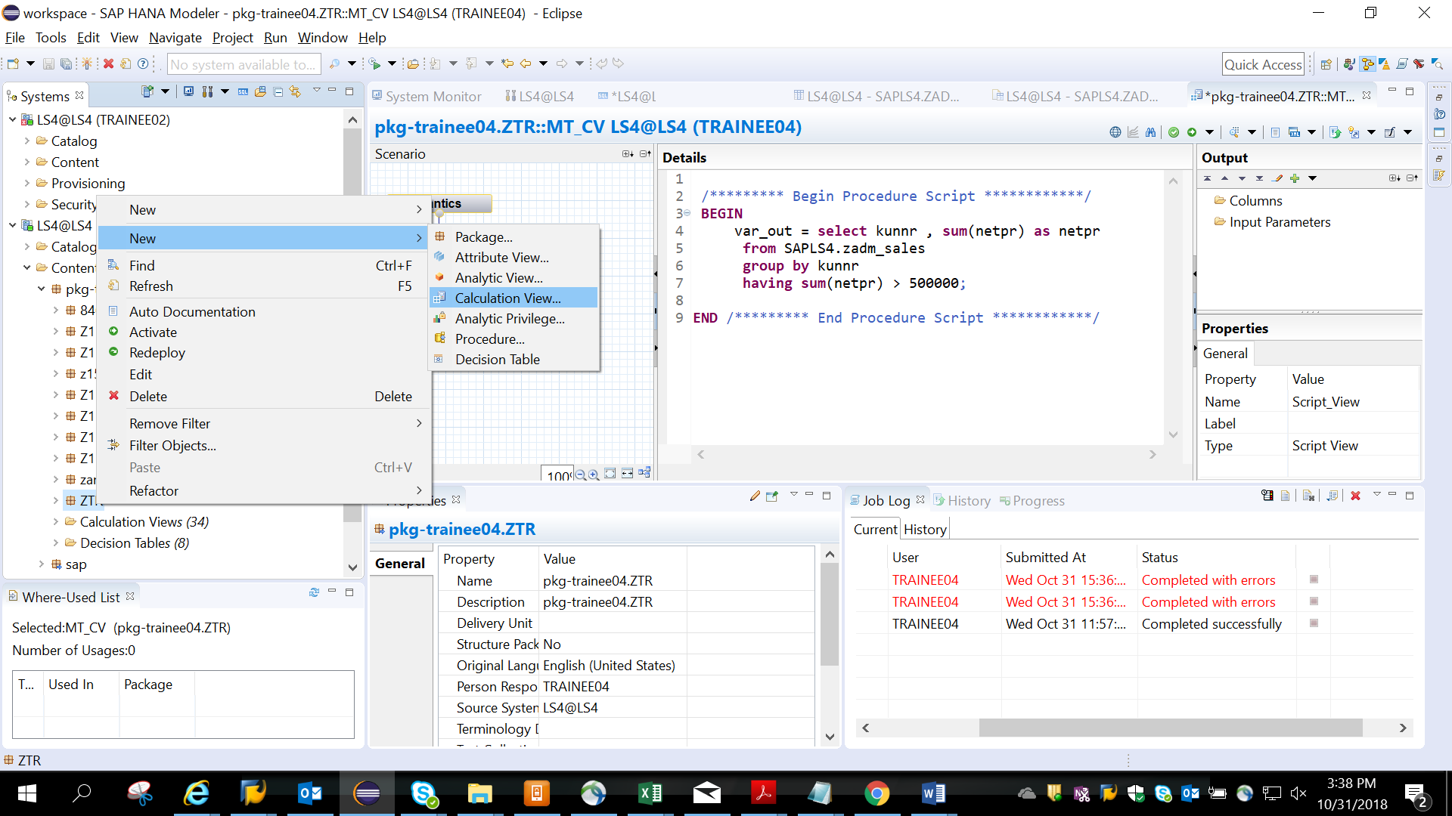

3) Given name to the view name MT_CV- choose sql script- finish.

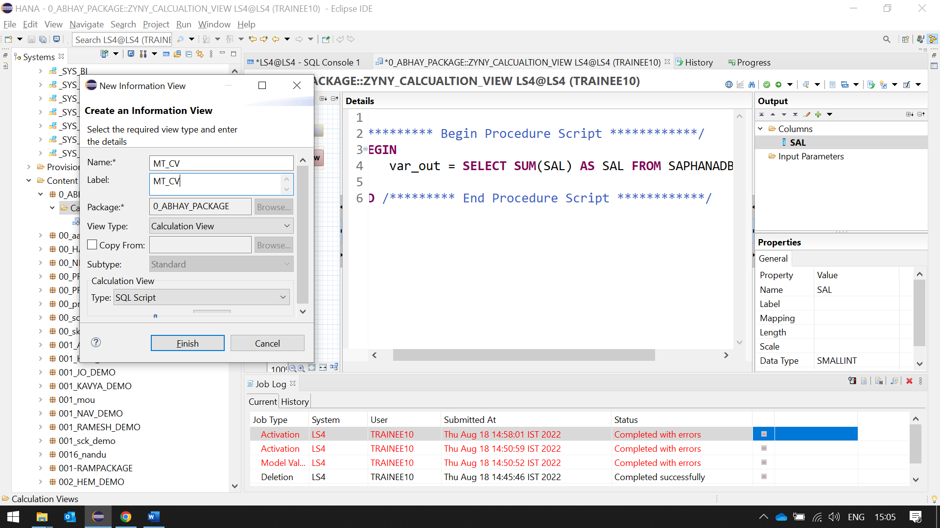

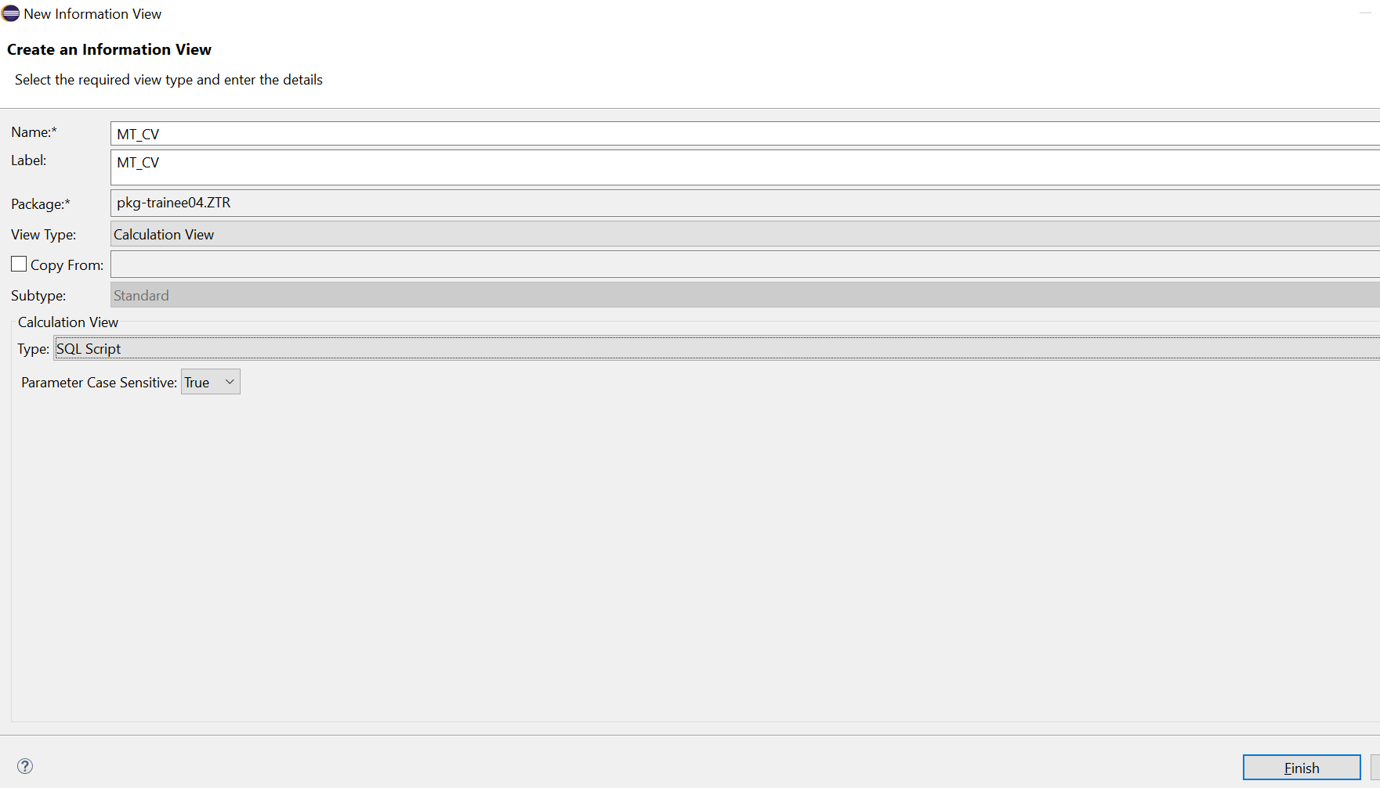

4) Click on the Script view and add the below code

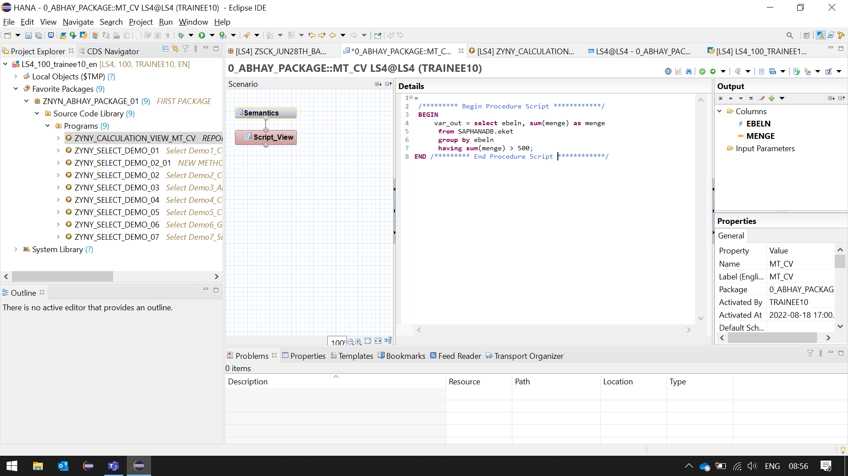

/********* Begin Procedure Script ************/

**BEGIN**

var_out = **select** ebeln, **sum**(menge) **as** menge

**from** SAPHANADB.eket

**group** **by** ebeln

**having** **sum**(menge) > 500;

**END** /********* End Procedure Script ************/

5) To Add the filed names, go to Right corner Output tab- drop down- Add Columns from

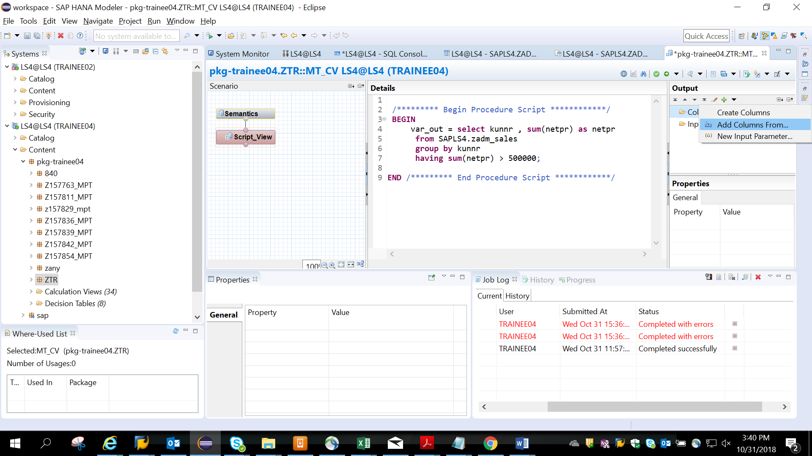

6)Give name of table created in se11

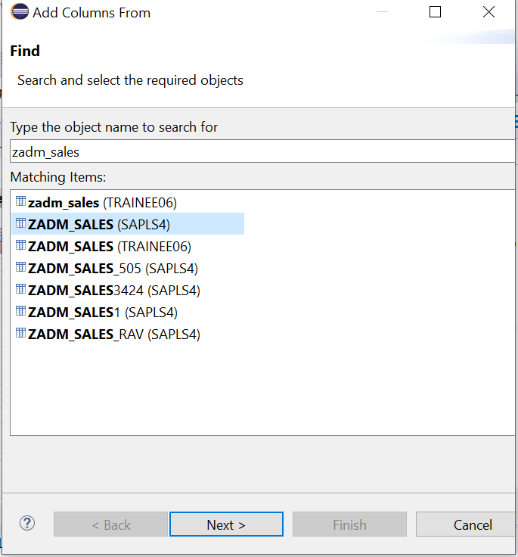select EKET

6)Add kunnr and netpr. Finish.

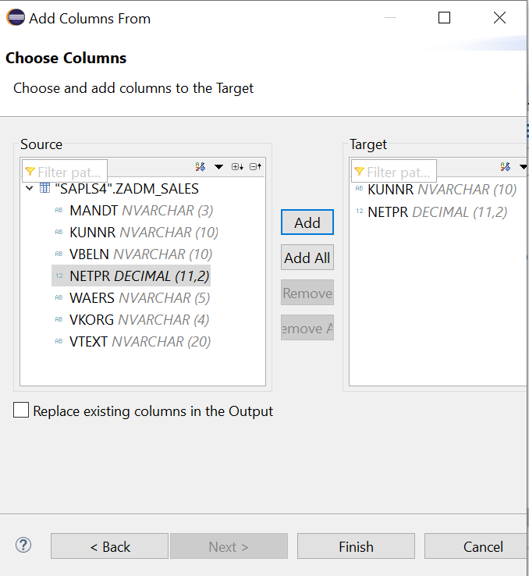

EBELN AND MENGE are added

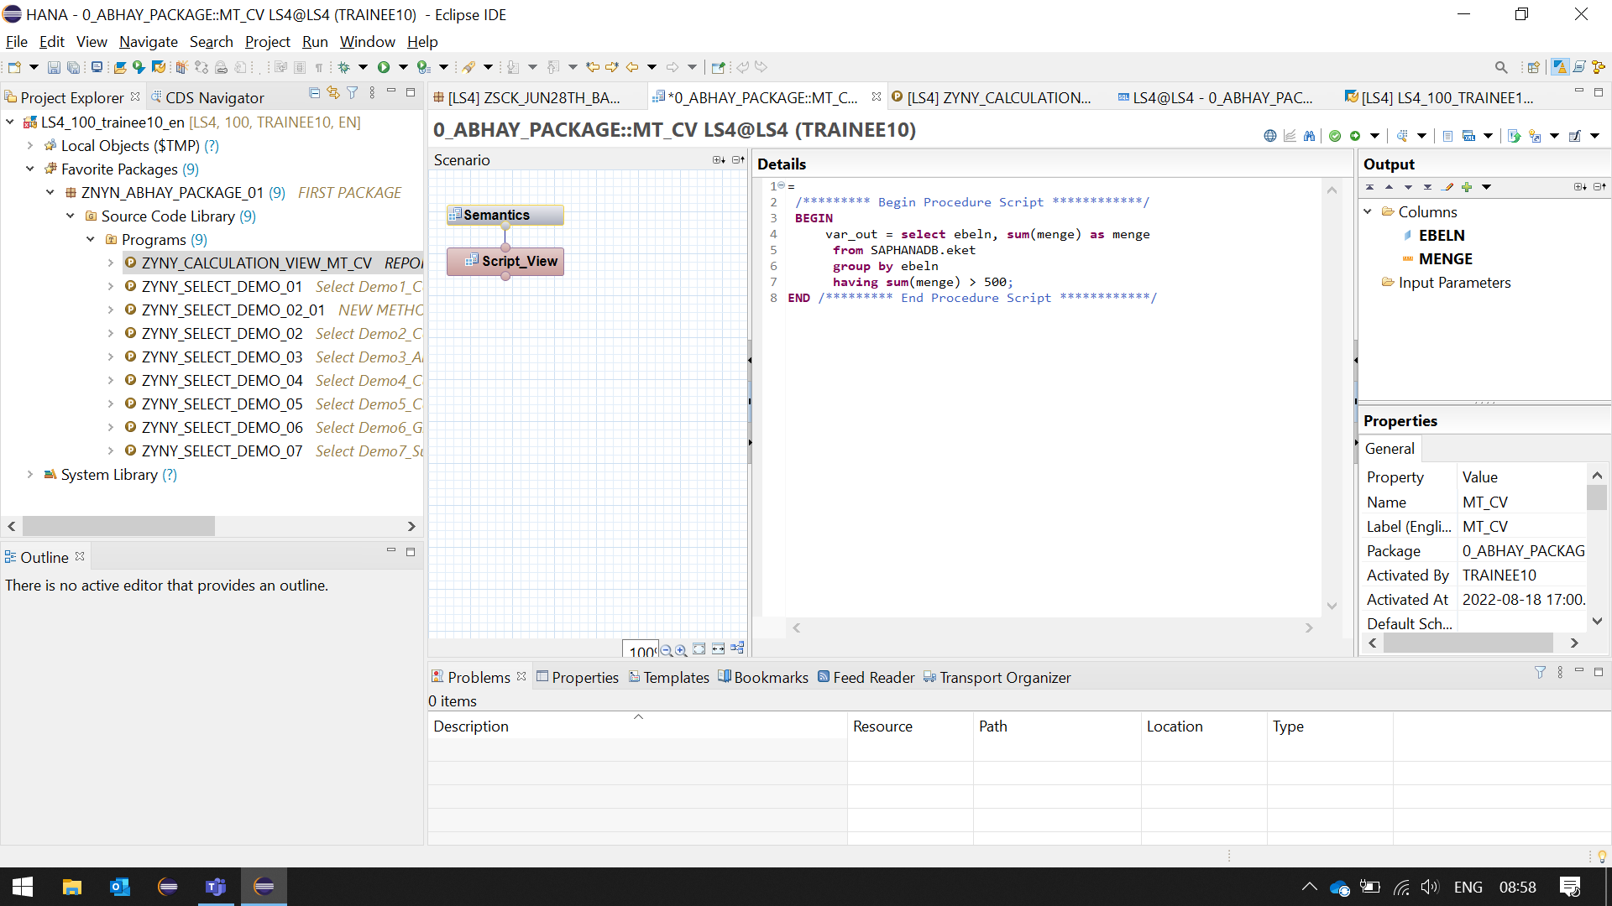

7)Save and activate

8)Confirm view is created by going to the path as shown

Inactive view will have the diamond symbol.

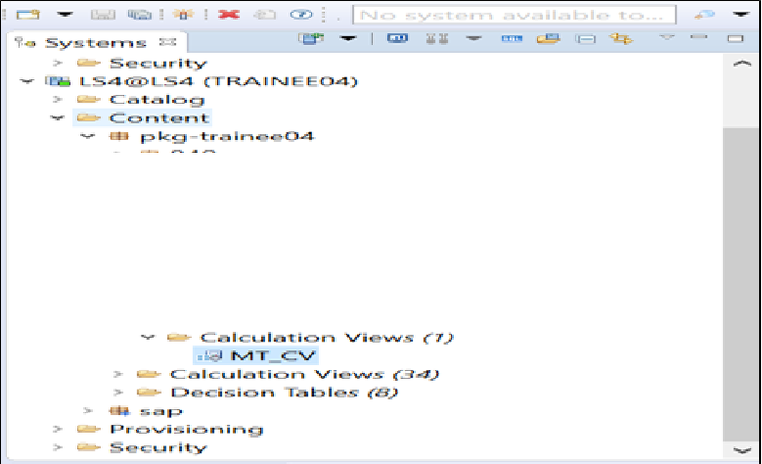

9)Right click on view-activate

Active view will not have the diamond symbol.

10) Right click on view name- Generate select sql

11)You will see the code like the one generated below.

Note: The package names and sub package names may be different

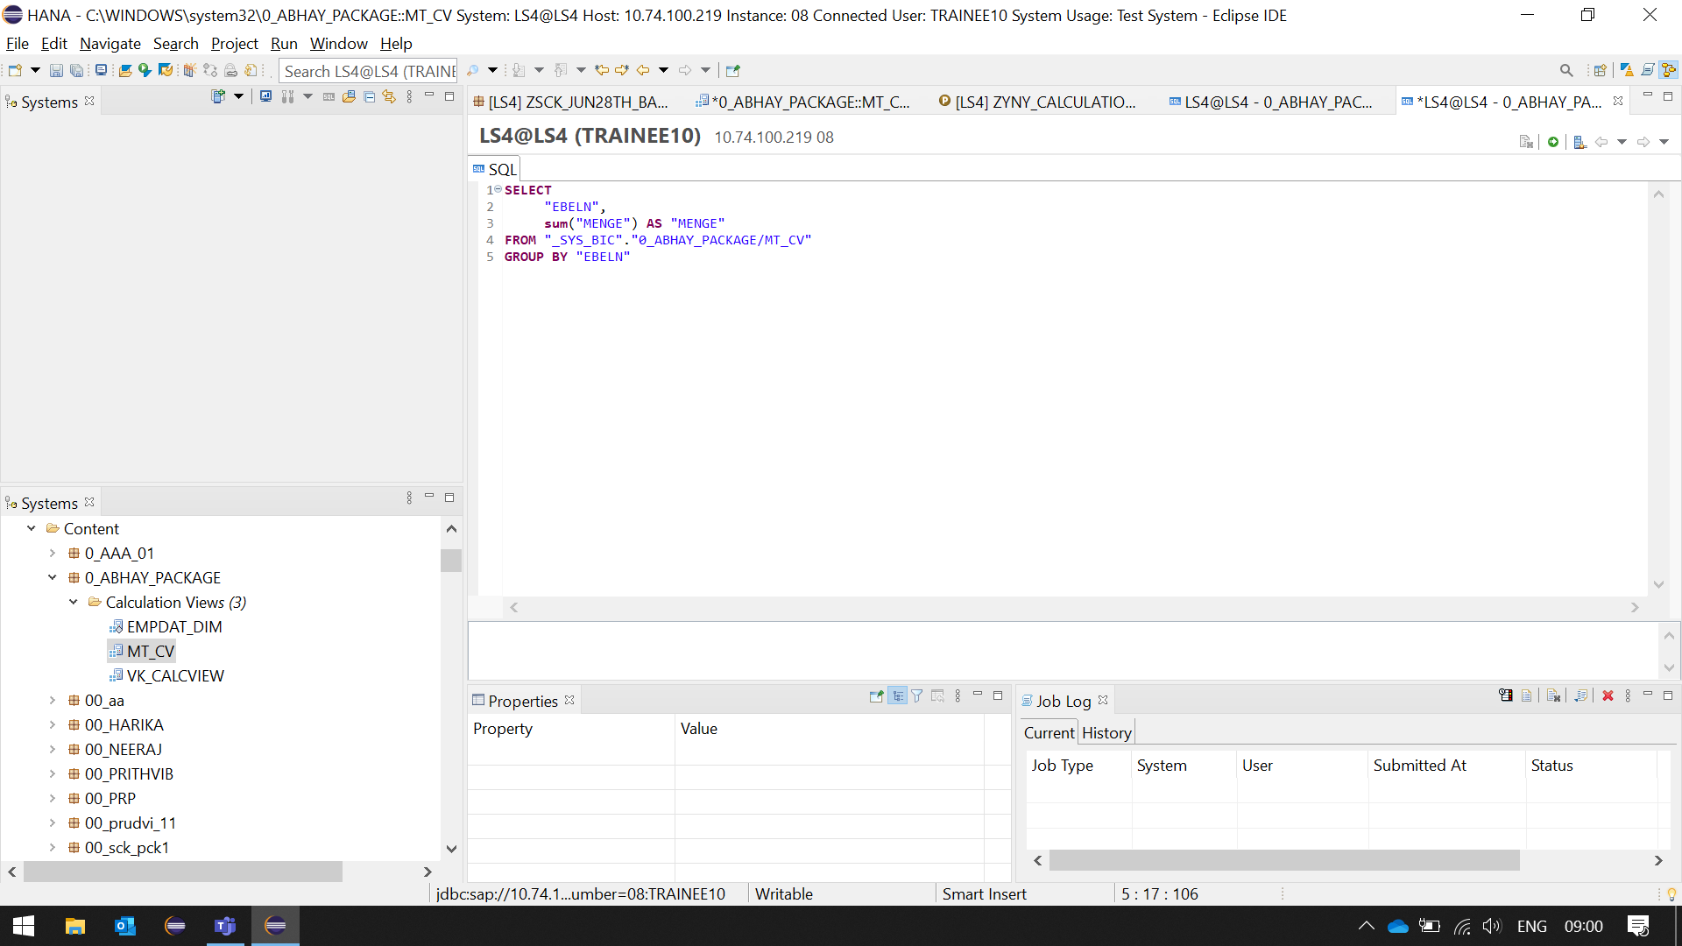

6)You can also check the view in the SYS_BIC schema

